WEB TECH DA 1(PROJECT){CLIENT-SIDE}

MEMBER 1:-

NAME:-B L RAMA KRISHNA

REGNO:-18BIT0175

MEMBER 2:-

NAME:-ROHAN

REGNO:-

TITLE:-FOODCULTURE(RESTURANT)

SUBMITTED TO:-PROF.VIJAYAN R

Webpages:

Foodculture(home page):-

Code:-

<!DOCTYPE html>

<html>

<head>

<meta charset="utf-8">

<title>

Food Culture

</title>

<style>

body {

background-color: black;

background-image: url("RESTURANT PIC BACKGROUND.jpg");

color: white;

padding: 10px;

text-align: center;

}

.slide{

position:relative;

left:400px;

}

#head {

position: relative;

font-size: 40px;

font-family: Georgia;

color: yellowgreen;

}

#logo {

float: left;

height: 250px;

width: 250px;

}

#d2 {

height: 200px;

margin-top: 80px;

background-size: 100% 100%;

color:aqua;

}

#head1 {

color:aqua;

text-align: center;

font-size: 40px;

}

#nav {

text-align: center;

}

#nav ul,

#nav li {

list-style-type: none;

}

#nav li {

padding: 15px;

display: inline-block;

}

#nav li a {

color:aqua;

font-size: 25px;

}

a {

outline: none;

text-decoration: none;

text-transform: capitalize;

font-size: 20px;

}

a:link {

color: #265301;

}

a:visited {

color: #437A16;

}

a:focus {

border-bottom: 1px solid;

background: #BAE498;

}

a:hover {

border-bottom: 1px solid;

background-color: rgba(255, 255, 255, 0.3);

}

a:active {

background: #265301;

color: #CDFEAA;

}

#nav {

position: relative;

}

#d3 {

background-color: #f2f2f2;

width: 100%;

height: 100%;

}

iframe {

margin: 40px;

}

#vid {

border-style: outset;

background-color: black;

box-shadow: 5px 5px 5px green;

border-radius: 10px;

}

#vid:hover {

background-color: green;

}

#foot {

border-style: outset;

background-color: gray;

border-radius: 5px;

}

.p {

font-family: georgia;

}

.section {

background-color: rgba(255, 255, 255, 0.8);

color: black;

margin: 40px 50px;

padding: 40px;

}

hr {

color: black;

background-color: black;

height: 2px;

margin: 40px auto;

max-width: 350px;

text-align: center;

}

</style>

</head>

<body>

<img src="fc.jpg" id="logo">

<h1 id="head">Food Culture</h1>

<div id="d2">

<h1 id="head1"><b>LATE NIGHT AT OFFICE?<br>WE ARE HERE!!!</b></h1>

<nav id="nav">

<ul>

<li><a href="foodculture.html" ><b>HOME</b></a></li>

<li><a href="menu.html" ><b>MENU</b></a></li>

<li><a href="onlinereservation.html"><b>ONLINE RESERVATION</b></a></li>

<li><a href="feedback.html"><b>FEEDBACK</b></a></li>

</ul>

<nav>

</div>

<div class="slide" style="max-width:500px">

<img class="mySlides" src="burger.jpg" style="width:100%">

<img class="mySlides" src="starters.jpg" style="width:100%">

<img class="mySlides" src="maincourse.jpg" style="width:100%">

</div>

<script>

var myIndex = 0;

carousel();

function carousel() {

var i;

var x = document.getElementsByClassName("mySlides");

for (i = 0; i < x.length; i++) {

x[i].style.display = "none";

}

myIndex++;

if (myIndex > x.length) {myIndex = 1}

x[myIndex-1].style.display = "block";

setTimeout(carousel, 2000); // Change image every 2 seconds

}

</script>

<div class="section">

<h1>

<font color=rgb(14,219,93)>WHAT IS ITALIAN CUSINE</font>

</h1>

<p class="p">Italy is one of the leading countries of the world and it has been so since the early times. Italian culture is rich and detailed.

Whether its food, architecture, philosophy, or fashion, they have been at the top of the game.

If you ever take a trip to Italy, you can experience their rich culture and

experience some of the best-known delicacies of the world. Italians are good at everything,

even partying to death. Tourism in Italy is growing each and every year.

</p>

<u><a href="https://en.wikipedia.org/wiki/Italian_cuisine" target="_blank">know more..</a></u>

<hr/>

<h1>

<font color=rgb(14,219,93)>WHAT IS CHINESE CUSINE</font>

</h1>

<p class="p">Indian cuisine consists of a wide variety of regional and traditional

cuisines native to the Indian subcontinent. Given the range of diversity in soil type,

climate, culture, ethnic groups, and occupations, these cuisines vary substantially from

each other and use locally available spices, herbs, vegetables, and fruits. Indian food is also heavily influenced

by religion, in particular Hinduism, cultural choices and traditions.</p>

<u><a href="https://en.wikipedia.org/wiki/Indian_cuisine" target="_blank">know more..</a></u>

<hr />

<h1>

<font color=rgb(14,219,93) face="georgia"><u>EXPERT COOK'S DISHES</u></font>

</h1>

<div id="vid">

<iframe width="560" height="315" src="https://www.youtube-nocookie.com/embed/1s_mO8F4x50" frameborder="0" allow="accelerometer;

autoplay; encrypted-media; gyroscope; picture-in-picture" allowfullscreen></iframe>

<iframe width="560" height="315" src="https://www.youtube-nocookie.com/embed/HQt66gXwJM8" frameborder="0" allow="accelerometer;

autoplay; encrypted-media; gyroscope; picture-in-picture" allowfullscreen></iframe>

</div>

<hr />

<div>

<h1><font color=rgb(14,219,93)>About Us:</font></h1>

<p>we serve a wide variety of authentic Hyderabad, Indian and Indo Chinese cuisine to our guests.

Cooking is an art and our chefs have mastered the art by combining traditional recipes with their own

personal and progressive approach. Every delicious dish that leaves our kitchen is created by one of our highly experienced chefs.

Whether you eat a simple chicken tikka kebab or our signature dish Hyderabad Nawabi Chicken Dum Biryani,

your tummy will thank us for the fresh and delicious food.</p>

</div>

</div>

</body>

</html>

Screenshot:-

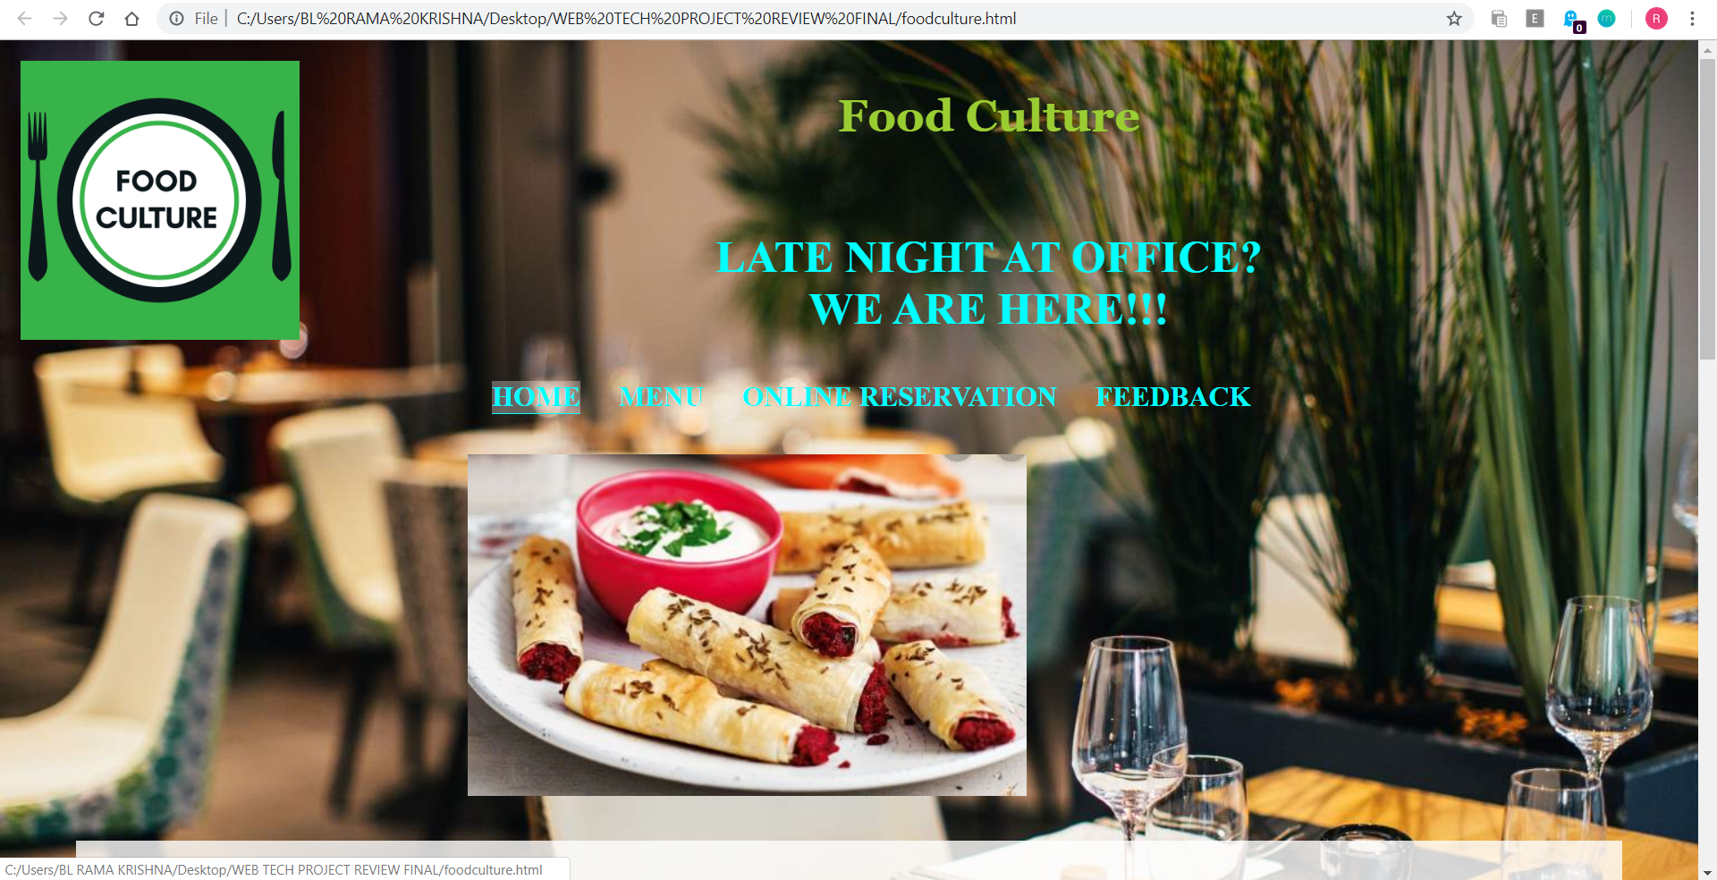

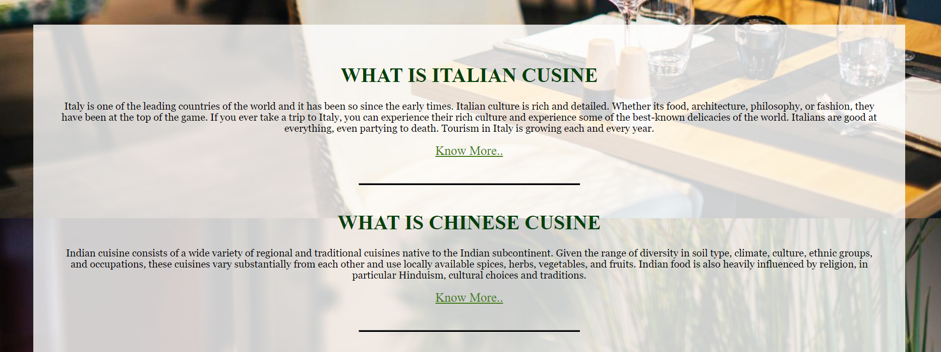

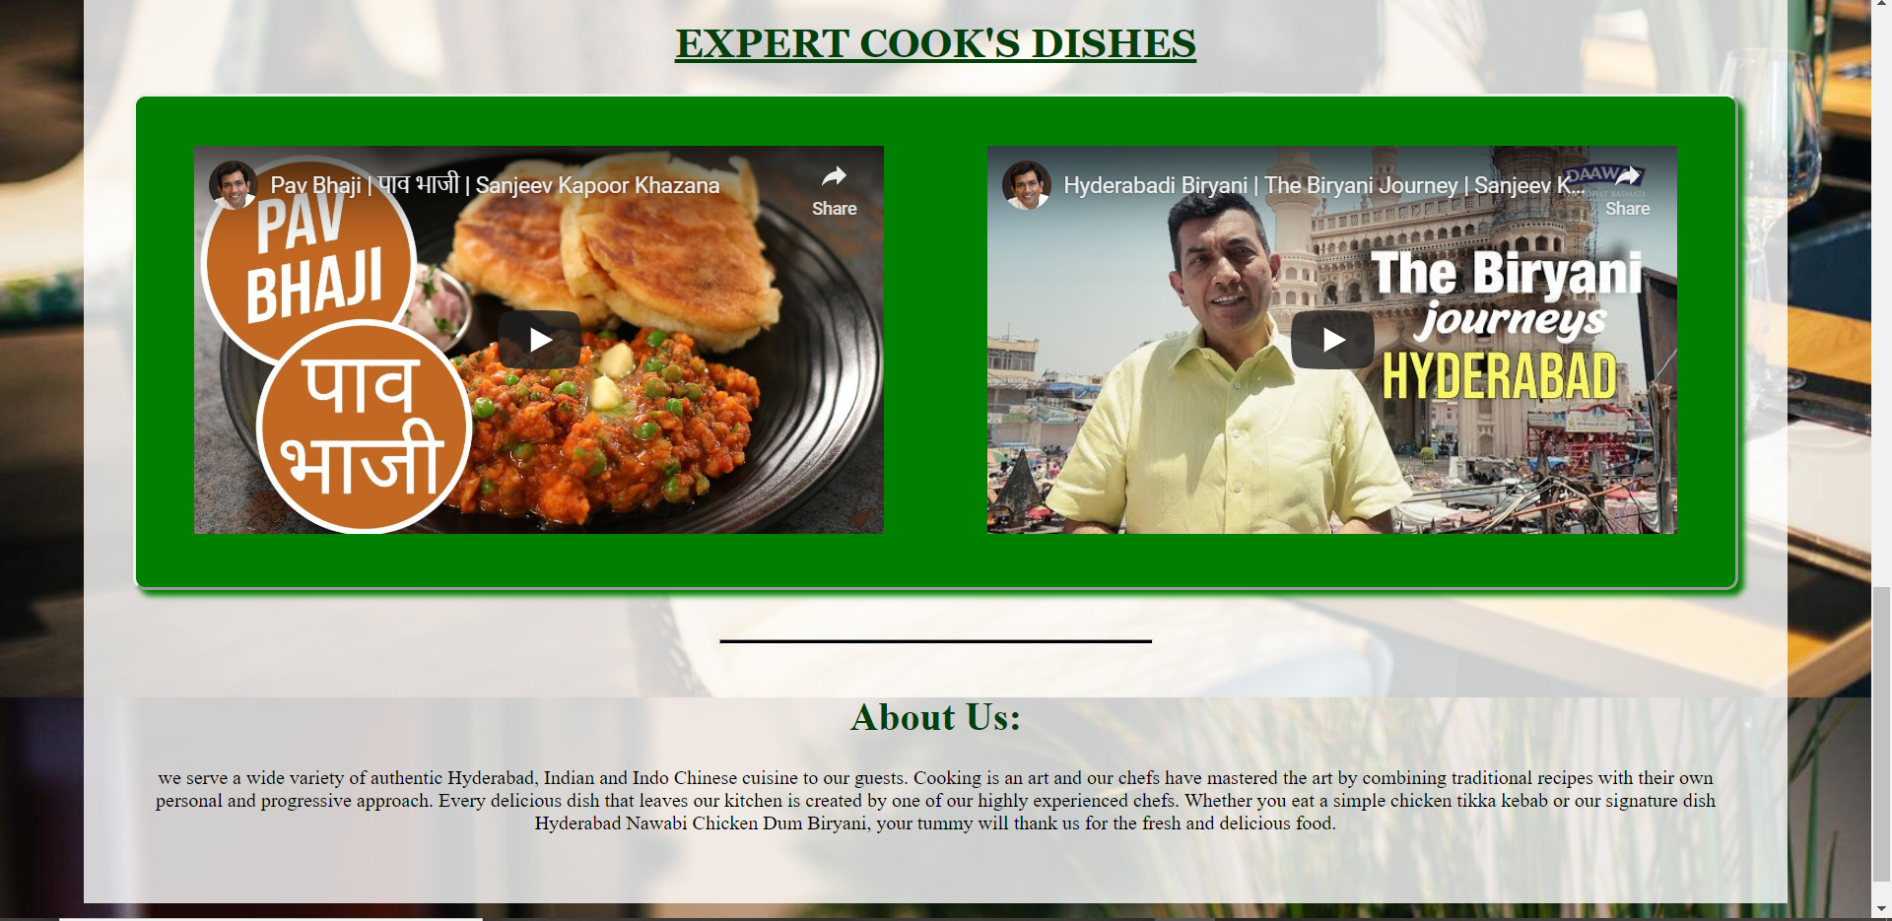

MENU:-

CODE:-

<html>

<head>

<meta charset="utf-8">

<script src="https://ajax.googleapis.com/ajax/libs/angularjs/1.6.9/angular.min.js"></script>

<style>

body {

background-color: black;

color: white;

background-image: url("RESTURANT PIC BACKGROUND.jpg");

padding: 10px;

text-align: center;

}

hr {

border: dotted #66FF00 6px;

border-bottom: none;

width: 5%;

margin: 10px auto;

}

a {

color: white;

}

.e {

border-radius: 10px;

background-color: rgba(255, 255, 255, 0.8);

color: black;

width: 70%;

padding: 10px;

margin: 15px auto;

display: inline-block;

text-align: center;

}

.e:hover {

transform: scale(1.07);

}

.ab1 {

border-radius: 50px;

background-color: black;

color: white;

float: left;

margin-left: 5%;

display: inline-block;

height: 300px;

width: 40%;

padding-left: 15px;

}

.ab2 {

border-radius: 50px;

background-color: black;

margin-left: 5%;

display: inline-block;

color: white;

height: 300px;

width: 40%;

padding-left: 15px;

box-sizing: border-box;

}

.ab1:hover {

background-color: yellowgreen;

font-weight: bold;

}

.ab2:hover {

background-color: aqua;

font-weight: bold;

}

.a1 {

float: right;

}

.search {

padding: 10px;

border-radius: 40px;

}

.search:focus {

outline: none;

}

#head {

color:violet;

position: relative;

font-size: 40px;

font-family: Georgia;

margin-top: 27px;

}

#logo {

float: left;

height: 100px;

width: 100px;

}

#d2 {

height: 200px;

margin-top: 80px;

background-size: 100% 100%;

}

#head1 {

color:aquamarine;

text-align: center;

font-size: 40px;

}

#nav {

text-align: center;

}

#nav ul,

#nav li {

list-style-type: none;

}

#nav li {

padding: 15px;

color:aquamarine;

display: inline-block;

}

#nav li a {

color:yellowgreen;

font-size: 25px;

text-decoration: none;

}

#nav li a:hover {

border-bottom: 1px solid;

background-color: rgba(255, 255, 255, 0.3);

}

</style>

</head>

<body>

<img src="menu.jpg"

id="logo">

<h1 id="head">MENU</h1>

<div id="d2">

<h1 id="head1"><b>ORDER IT!!!ENJOY IT!!!</b></h1>

<nav id="nav">

<ul>

<li><a href="foodculture.html"><b>HOME</b></a></li>

<li><a href="menu.html"><b>MENU</b></a></li>

<li><a href="onlinereservation.html"><b>ONLINE RESERVATION</b></a></li>

<li><a href="feedback.html"><b>FEEDBACK</b></a></li>

</ul>

<nav>

</div>

<hr><br>

<div ng-app="myapp" ng-controller="namesCtrl">

<div class="ab1">

<p>

<center>

<h1>Starters</h1>

</center>

</p><br>

<center><img src="starters.jpg" height="110px" width="110px"></center><br><br>

<p class="a1">

<center>a small dish of food or a drink taken before a meal or the main course of a meal, these tit-bits

of food are known to increase appetite and thus known as Appetizers</center>

</p>

</div>

<div class="ab2">

<p>

<center>

<h1>Main course</h1>

</center>

</p><br>

<center><img src="maincourse.jpg" height="110px" width="110px"></center><br><br>

<p class="a1">

<center>The main dish is usually the heaviest, heartiest, and most complex or substantial dish in a meal.

The main ingredient is usually meat, fish or another protein source.</center>

</p>

</div>

<br><br>

<p>

<center> <input class="search" type="text" ng-model="test" placeholder="ENTER DISH"></center>

</p>

<div ng-show="myVar1" class="e" ng-repeat="x in names1 | filter:test">

<h1>{{x.name}}</h1><br />

<p>{{x.info}}</p>

</div>

<script>

angular.module('myapp', []).controller('namesCtrl', function ($scope) {

$scope.myVar1 = true;

$scope.change = function (num) {

if (num === 1) {

$scope.myVar1 = true;

} else if (num === 2) {

$scope.myVar1 = false;

}

}

$scope.names1 = [{

"name": "KAMAAL KA PUCHKA",

"info": "Baby puffs with sprouts, chutney and crispy chaat stuffing"

},

{

"name": "VEGETARIAN TASTING PLATTER",

"info": "An assortment of choicest starters, samosa, paneer tikka, mushrooms and kothimbir wadi"

},

{

"name": "JAIPURI TIKKI",

"info": "Crispy asparagus & pinenut paneer tikki coated with lentil strips"

},

{

"name": "DAL TADKA",

"info": "Mixed yellow beans freshly tempered with cumin and asafoetida"

},

{

"name": "CAULIFLOWER AND POTATO MASALA ",

"info": "Traditional aloo phoolgobi masala tempered with brown onions and cumin"

},

{

"name": "COTTAGE CHEESE BHUNA MAKHNI",

"info": "Fresh paneer cubes tossed in butter in a tomato makhni sauce"

},

{

"name": "PALAK PANEER",

"info": "A Punjabi delicacy of spinach and cottage cheese, a world famous dish"

},

{

"name": "KERALA KUTTU WITH APPAM",

"info": "Mix spring vegetables in a coconut curry with fluffy rice hoppers- a Kerala specialty"

},

{

"name": "TANDOORI SMOKED AUBERGINE ",

"info": "Tandoor roasted aubergine hash Punjabi style also called Baingan Bharta "

},

];

});

</script>

</body>

</html>

SCREENSHOT:-

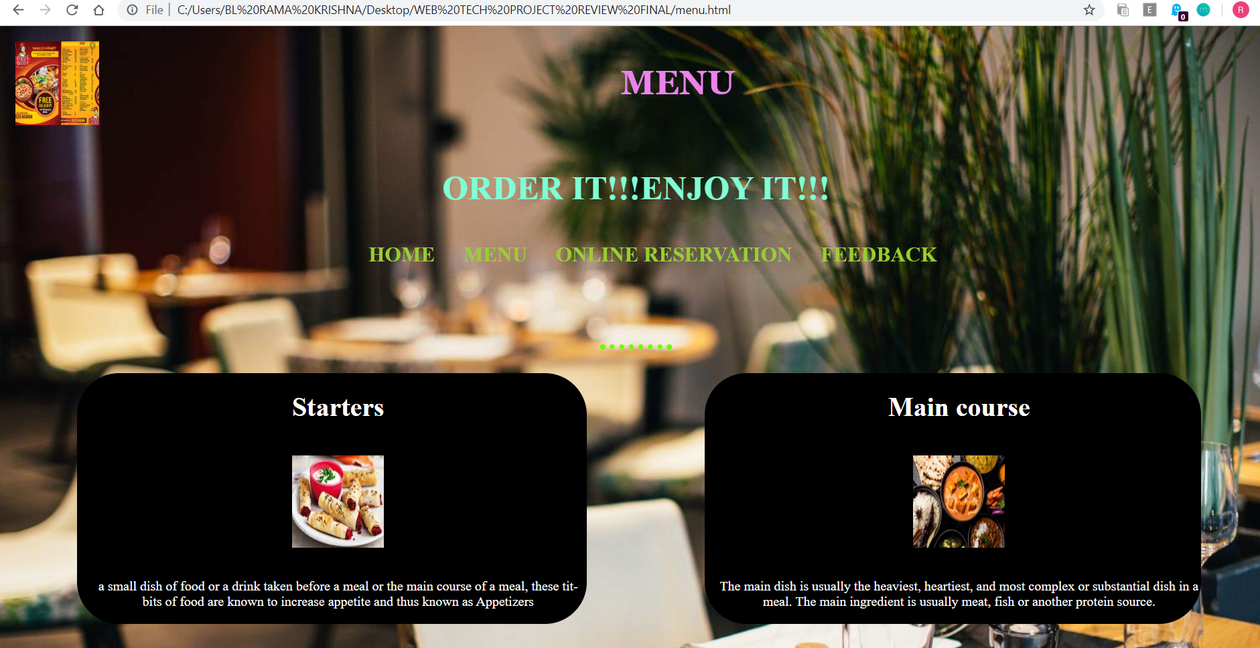

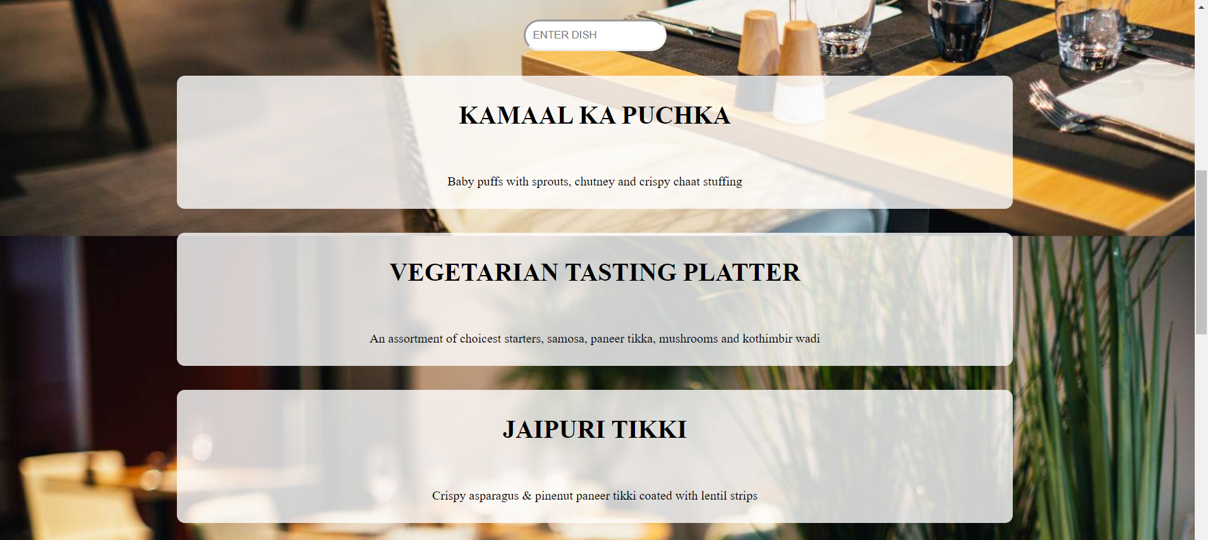

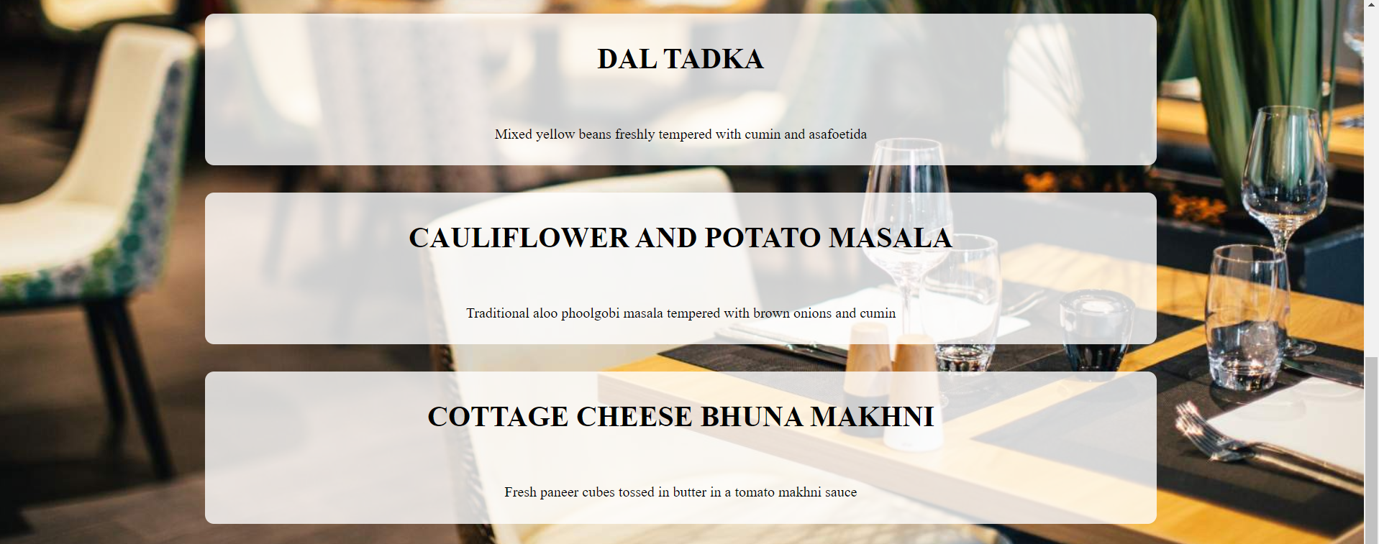

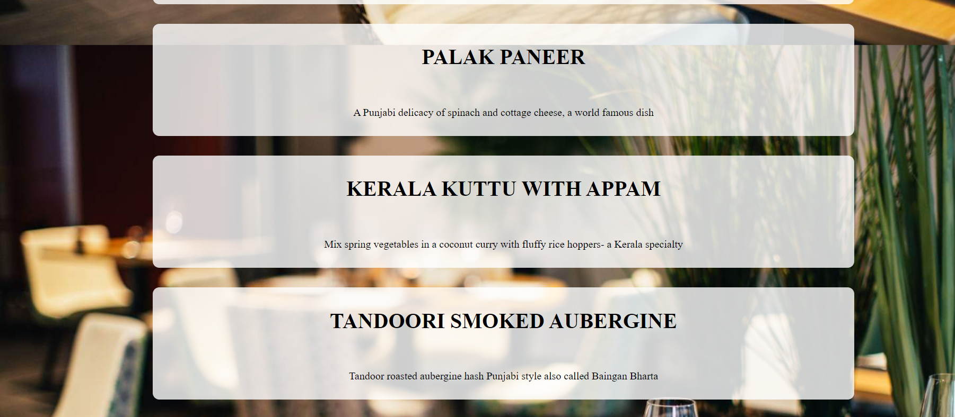

ONLINE RESERVATION:-

CODE:-

<!DOCTYPE html>

<html>

<head>

<title>Online Reservation</title>

<script type="text/javascript"></script>

<style>

#nav {

text-align: center;

}

#nav ul,

#nav li {

list-style-type: none;

}

#nav li {

padding: 15px;

color:aqua;

display: inline-block;

}

#nav li a {

color:yellowgreen;

font-size: 25px;

}

a {

outline: none;

text-decoration: none;

text-transform: capitalize;

font-size: 20px;

}

a:hover {

border-bottom: 1px solid;

background-color: rgba(255, 255, 255, 0.3);

}

#d2 {

height: 200px;

text-align: center;

margin-top: 20px;

background-size: 100% 100%;

color:aqua;

}

body {

background-color: black;

background-image: url("RESTURANT PIC BACKGROUND.jpg");

color: white;

padding: 10px;

}

.form{

background-color: #fff;

width: 450px;

position:relative;

left:400px;

opacity: 0.9;

color: black;

border-radius: 20px;

}

form div{

padding: 10px;

opacity: 1;

}

</style>

</head>

<body>

<div id="d2">

<h1>Online Reservation</h1>

<nav id="nav">

<ul>

<li><a href="foodculture.html" ><b>HOME</b></a></li>

<li><a href="menu.html" ><b>MENU</b></a></li>

<li><a href="onlinereservation.html"><b>ONLINE RESERVATION</b></a></li>

<li><a href="feedback.html"><b>FEEDBACK</b></a></li>

</ul>

<nav>

</div>

<div class="form">

<form method="post" onSubmit="return validateForm();">

<div style="width: 400px;">

</div>

<div style="padding-bottom: 18px; text-align: center; font-size: 25px;">Table Reservation</div>

<div style="padding-bottom: 18px;">We would be glad to reserve a table for you at our restaurant!</div>

<div style="padding-bottom: 18px;">Name<span style="color: red;"> *</span><br/>

<input type="text" id="name" name="name" style="width : 400px;" />

</div>

<div style="padding-bottom: 18px;">Phone<br/>

<input type="text" id="phone" name="phone" style="width : 400px;" />

</div>

<div style="padding-bottom: 18px;">Email<br/>

<input type="text" id="email" name="email" style="width : 400px;"/>

</div>

<div style="padding-bottom: 18px;">Date<span style="color: red;"> *</span><br/>

<input type="date" id="date" name="date" style="width : 250px;"/>

</div>

<div style="padding-bottom: 18px;">Time<span style="color: red;"> *</span><br/>

<input type="text" id="time" name="time" style="width : 250px;"/>

</div>

<div style="padding-bottom: 18px;">Number of Attendees<span style="color: red;"> *</span><br/>

<select id="attendees" name="attendees" style="width : 250px;" ><option>1</option>

<option>2</option>

<option>3</option>

<option>4</option>

<option>5</option>

<option>6</option>

<option>7</option>

<option>8</option>

<option>9</option>

<option>10</option>

<option>10+ (Specify in Comments)</option>

</select>

</div>

<div style="padding-bottom: 18px;">Comments / Additional Requests<br/>

<textarea id="data_9" false name="data_9" style="width : 400px;" rows="6" class="form-control"></textarea>

</div>

<div style="padding-bottom: 18px; text-align:center"><input name="skip_Submit" value="Submit" type="submit"/></div>

<div>

</form>

</div>

<script type="text/javascript">

function validateForm() {

if (isEmpty(document.getElementById('name').value)) {

alert('Name is required!');

return false;

}

if (!validateEmail(document.getElementById('email').value)) {

alert('Email must be a valid email address!');

return false;

}

if (isEmpty(document.getElementById('date').value)) {

alert('Date is required!');

return false;

}

if (isEmpty(document.getElementById('time').value)) {

alert('Time is required!');

return false;

}

return true;

}

function isEmpty(str) { return (str.length === 0); }

function validateEmail(email) {

var re = /^([\w-]+(?:\.[\w-]+)*)@((?:[\w-]+\.)*\w[\w-]{0,66})\.([a-z]{2,15}(?:\.[a-z]{2})?)$/i;

return isEmpty(email) || re.test(email);

}

</script>

</body>

</html>

SCREENSHOT:-

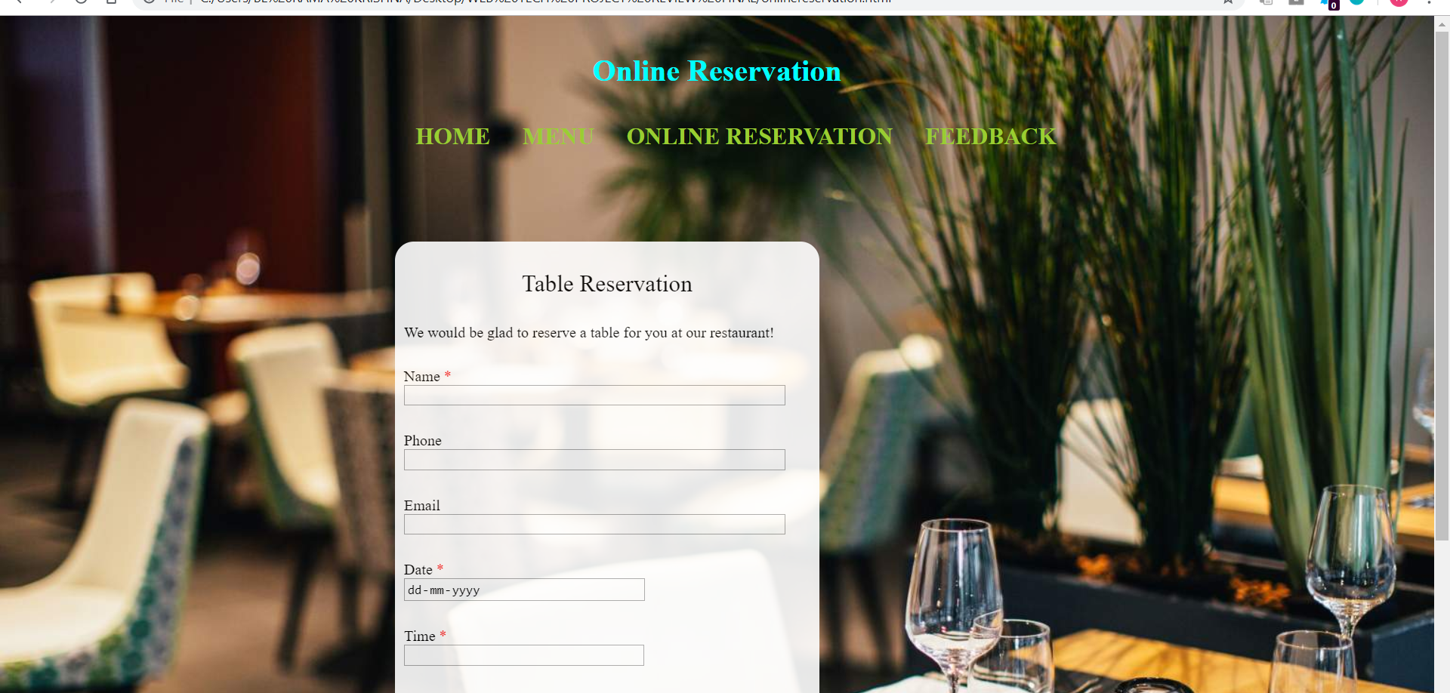

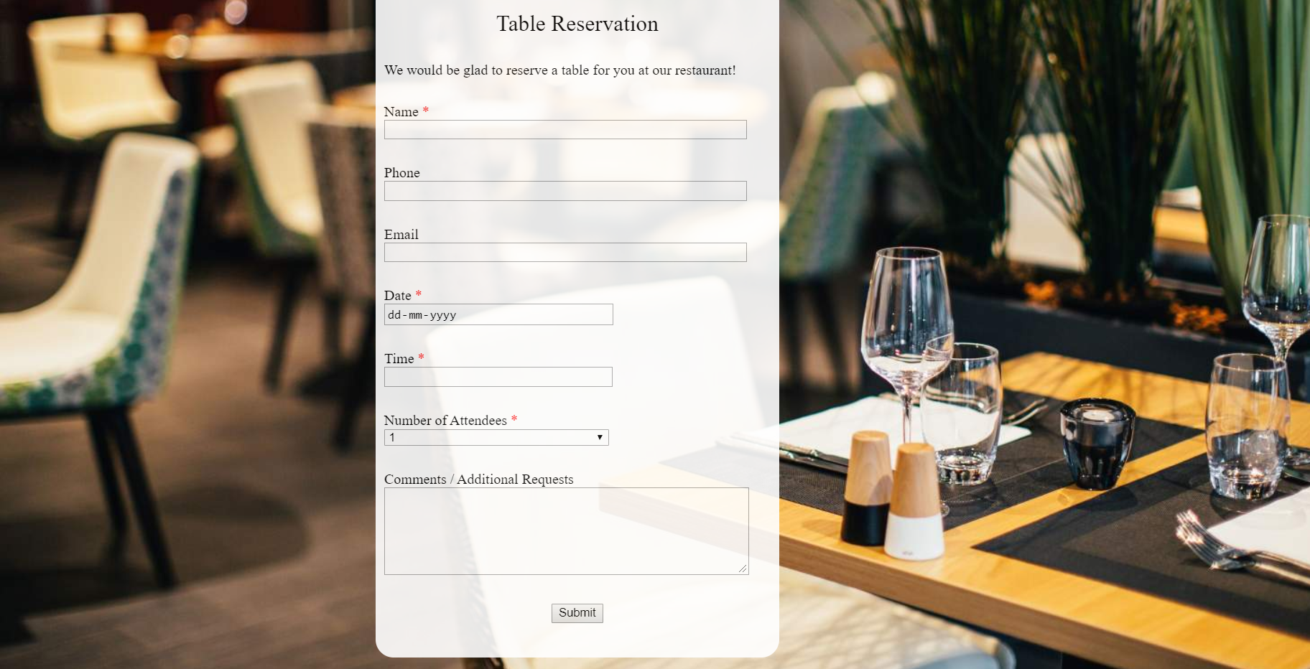

HANDLING EXCEPTIONS:-

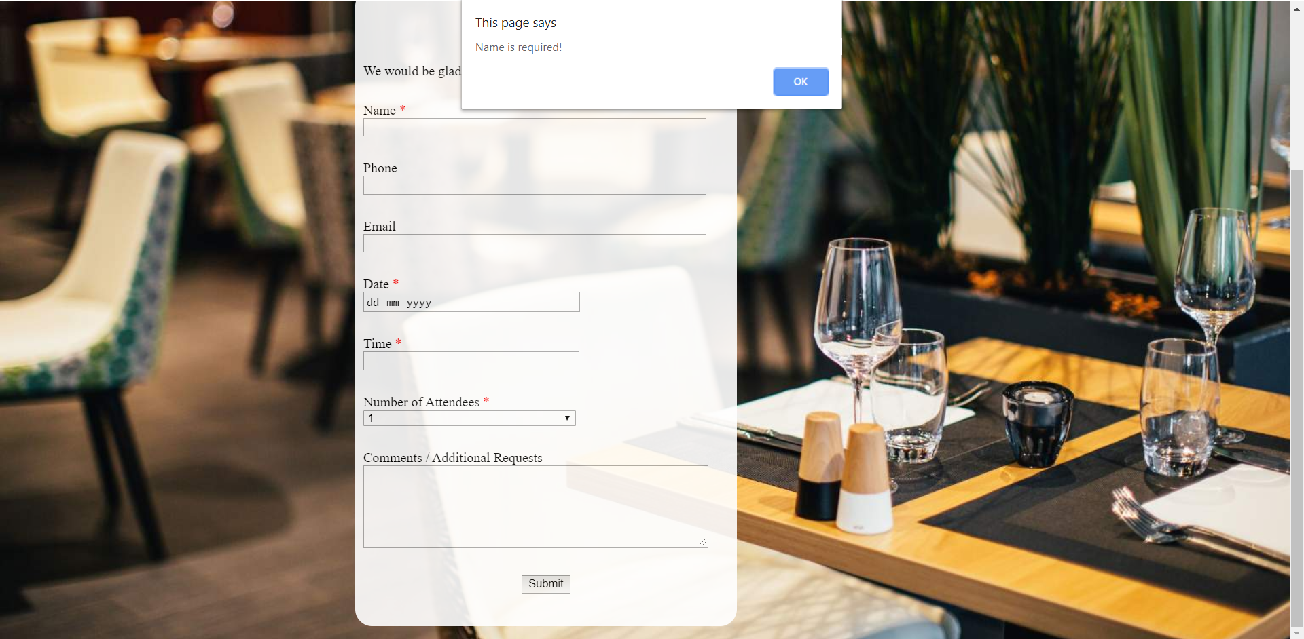

FEEDBACK FORM:-

CODE:-

<!doctype html>

<html>

<head meta charset="utf-8">

<title>Feedback</title>

<script src="https://code.jquery.com/jquery-3.3.1.min.js"

integrity="sha256-FgpCb/KJQlLNfOu91ta32o/NMZxltwRo8QtmkMRdAu8=" crossorigin="anonymous"></script>

<script src="https://ajax.googleapis.com/ajax/libs/jquery/3.3.1/jquery.min.js"></script>

<style>

input {

border-radius: 10px;

padding: 5px;

height: 30px;

position: relative;

left: 0;

outline: none;

border: 1px solid #cdcdcd;

border-color: rgba(0, 0, 0, .15);

background-color: white;

font-size: 15px;

}

textarea {

border-radius: 15px;

font-size: 15px;

padding: 10px;

}

body {

background-color: black;

background-image: url("RESTURANT PIC BACKGROUND.jpg");

color: white;

padding: 10px;

}

button {

border: 0;

width: 270px;

padding: 10px;

margin: 20px auto;

border-radius: 5px;

text-align: center;

font-family: cursive;

font-size: 1.2em;

}

button:active {

margin-top: 22px;

}

.green {

color: #FFF;

background: #8bbc37;

position:relative;

left:80px;

}

.green:hover {

background: #85b237;

}

p {

font-weight: bolder;

font-size: 30px;

align-content: center;

}

#d1 {

background-color: palevioletred;

height: 100px;

}

#head

{

position: relative;

font-size: 40px;

font-family: Georgia;

margin-top: 27px;

color:chocolate;

text-align: center

}

#logo {

float: left;

height: 150px;

width: 150px;

}

#d2 {

height: 200px;

margin-top: 80px;

background-size: 100% 100%;

}

#head1 {

color: aquamarine;

text-align: center;

font-size: 40px;

}

#nav {

text-align: center;

}

#nav ul,

#nav li {

list-style-type: none;

}

#nav li {

padding: 15px;

color: aquamarine;

display: inline-block;

}

#nav li a {

color:aqua;

font-size: 25px;

text-decoration: none;

}

#nav li a:hover {

border-bottom: 1px solid;

background-color: rgba(255, 255, 255, 0.3);

}

form{

color: black;

}

.form{

background-color: #fff;

width: 450px;

position:relative;

left:400px;

opacity: 0.9;

color: black;

border-radius: 20px;

}

form div{

padding: 10px;

}

</style>

</head>

<body>

<img src="feedback.jpeg"

id="logo">

<h1 id="head">FEEDBACK</h1>

<div id="d2">

<h1 id="head1"><b>Mistakes should be examined,

learned from, and discarded; not dwelled upon and stored </b></h1>

<nav id="nav">

<ul>

<li><a href="foodculture.html" ><b>HOME</b></a></li>

<li><a href="menu.html" ><b>MENU</b></a></li>

<li><a href="onlinereservation.html"><b>ONLINE RESERVATION</b></a></li>

<li><a href="feedback.html"><b>FEEDBACK</b></a></li>

</ul>

<nav>

</div>

<p><font color=aqua>Feedback Form :</font></p>

<div class="form">

<form>

<table cellspacing="10" align="center">

<tr>

<td>Name : <input id="name" type="text" placeholder="Your Name here"></td>

</tr>

<tr>

<td>Mobile: <input id="phone" type="text" placeholder="9XXXXXXXXX"></td>

</tr>

<tr>

<td>Email : <input id="email" type="text" placeholder="xyz@gmail.com"></td>

</tr>

<tr>

<td>Suggestions:</td>

</tr>

<tr>

<td><textarea id="message" rows="5" cols="50" placeholder="Enter your suggestions here"></textarea></td>

</tr>

<tr>

<td><button type="button" class="green" onclick="send()">Click here to submit</button></td>

</tr>

</table>

</form>

</div>

</body>

</html>

SCREENSHOT:-

